Pupil premium strategy statement – St John Vianney Catholic Primary School
Before completing this template, read the Education Endowment Foundation’s guide to the pupil premium and DfE’s pupil premium guidance for school leaders, which includes the ‘menu of approaches’. It is for school leaders to decide what activity to spend their pupil premium on, within the framework set out by the menu.
All schools that receive pupil premium are required to use this template to complete and publish a pupil premium statement on their school website by 31 December every academic year.
If you are starting a new pupil premium strategy plan, use this blank template. If you are continuing a strategy plan from last academic year, you may prefer to edit your existing statement, if that version was published using the template.

Before publishing your completed statement, delete the instructions (text in italics) in this template, and this text box.

This statement details our school’s use of pupil premium funding to help improve the attainment of our disadvantaged pupils.
It outlines our pupil premium strategy, how we intend to spend the funding in this academic year and the outcomes for disadvantaged pupils last academic year.

School overview
Detail | Data
Number of pupils in school | 233
Proportion (%) of pupil premium eligible pupils | 9%
Academic year/years that our current pupil premium strategy plan covers (3-year plans are recommended – you must still publish an updated statement each academic year) | 3 year plan 2025-28  This strategy Statement covers Year1 2025-26
Date this statement was published | Dec 2025
Date on which it will be reviewed | Nov 2026
Statement authorised by | Veronica Gosling
Pupil premium lead | Veronica Gosling
Governor / Trustee lead | Andrew Green

Funding overview
Detail | Amount
Pupil premium funding allocation this academic year | £32,207
Pupil premium funding carried forward from previous years (enter £0 if not applicable) | £0
Total budget for this academic year  If your school is an academy in a trust that pools this funding, state the amount available to your school this academic year | £32,207

Part A: Pupil premium strategy plan

Statement of intent
The mission of The Holy Cross Catholic MAC, which we align with at St John Vianney Catholic Primary School is ‘Our school communities are united as the family of God to provide an outstanding Catholic education for all our pupils. With Christ at the centre of all we do, we will inspire every child to be the best person they can be by developing their God given gifts and talents.’
Effective spend of pupil premium funding to effect excellent outcomes for our pupils is a whole school priority. With our drive to ensure high aspirations for all and to provide an outstanding education that enables pupils to reach their full potential academically and personally, we analyse data and draw on our close working relationships with pupils and families to identify and understand the barriers that our disadvantaged pupils face and offer effective, research-backed, value for money strategies to remove and overcome barriers. We recognise that prompt, early intervention is most effective in preventing gaps from growing.
Primary
Whilst our disadvantaged pupils achieve better than disadvantaged pupils nationally: Low numbers of disadvantaged in GLD make a comparison to national irrelevant; 100% passed the phonics screening compared to 66.8% nationally and 80% achieved expected in reading, writing and maths at KS2 compared to 45.1% nationally in 2025; we continue to strive to close the gap with non-disadvantaged pupils.
We combine our knowledge of the challenges affecting disadvantaged pupils in our school with the information available from the DfE in Using Pupil Premium: Guidance for School Leaders and the EEF Guide to Pupil Premium to inform our strategic planning to implement the three-tiered approach. We note that there is a clear overlap of pupils in receipt of PP funding who also have SEND and that a number of pupils receiving PP funding are high achievers: our PP strategy takes account of this. High quality teaching continues to form the foundation of our Pupil Premium strategy as this has been proven to have the greatest impact on closing the attainment gap. Additional targeted support is used to promote achievement where a need has been identified. Wider strategies are used to promote engagement, achievement and wellbeing based on the contextual knowledge and data analysis we hold on our children.
Strategies are used with relevant research informing our choice and in the knowledge that they are intended to support the needs of all pupils as well as those identified as disadvantaged.
There are only 21 pupils across the school therefore we have decided to focus upon quality first teaching and ways to develop this for the good of all pupils across the school.

Challenges
This details the key challenges to achievement that we have identified among our disadvantaged pupils.
Challenge number | Detail of challenge
1 | Assessments, observations, and discussions with pupils indicate underdeveloped oral language skills and vocabulary gaps among many disadvantaged pupils. These are evident from Reception through to KS2 and in general, are more prevalent among our disadvantaged pupils than their peers.
2 | Our assessments (including wellbeing survey), observations and discussions with pupils and families have identified social and emotional issues for many pupils, notably due to a lack of enrichment opportunities. These challenges particularly affect disadvantaged pupils, including their attainment.  Pupils may experience trauma, anxiety, or low self-esteem, which can hinder their ability to engage and learn effectively. Teacher referrals for support remain relatively high: 43% of children who are disadvantaged currently require additional support with social and emotional needs, and 57% of children who are disadvantage are receiving small-group interventions.  In addition, parental engagement remains a challenge for some families due to work commitments, travel arrangements to school, language barriers, or unfamiliarity with the curriculum. These factors can limit the support pupils receive at home, further widening gaps in learning.
3 | At St John Vianney Catholic Primary school we have noticed an increase of children with both PP and SEND and sometimes parents tend to engage less which has a negative impact upon progress.
4 | At St John Vianney Catholic Primary School, we have seen an increase in the number of children who have experienced trauma due to adverse childhood experiences (ACEs). These experiences can significantly impact a child’s ability to thrive academically and emotionally.

Intended outcomes
This explains the outcomes we are aiming for by the end of our current strategy plan, and how we will measure whether they have been achieved.
Intended outcome | Success criteria
To enable pupils to regulate their own behaviour | Increased training in RSHE for staff, support from the mental health and well being team, emotional coaching training for staff and parents  Reduction in dysregulated behaviours
Improved oral language skills and vocabulary among disadvantaged pupils. | Oracy training for staff delivery  Oracy action plan in place which targets support for all pupils  Assessments and observations indicate significantly improved oral language among disadvantaged pupils.  Evidence triangulated through engagement in lessons, book scrutiny, and ongoing formative assessment.
To achieve and sustain improved wellbeing for all pupils, particularly disadvantaged pupils. | Sustained high levels of wellbeing by 2027/28 demonstrated by:  • Qualitative data from pupil voice, parent surveys, and teacher observations  • Increased participation in enrichment activities, particularly among disadvantaged pupils
To strengthen parental engagement to support learning at home. | By 2027/28:  • Increased attendance at parent workshops and curriculum events  • Positive feedback from parent surveys  • Evidence of improved home learning support through homework completion and reading logs
To reduce the impact of trauma and social-emotional barriers on learning. | By 2027/28:  • Reduction in referrals for emotional support  • Increased engagement in lessons and improved attainment for pupils previously identified with high social-emotional needs  • Positive wellbeing survey results and improved resilience scores

Activity in this academic year
This details how we intend to spend our pupil premium funding this academic year to address the challenges listed above.

Teaching (for example, CPD, recruitment and retention)
Budgeted cost: £20,000
Activity | Evidence that supports this approach | Challenge number(s) addressed
Neli and Welcome used in Nursery and Reception  Oracy Training for staff  Elklan Speech and Language support | Oral language interventions can be an effective approach for disadvantaged pupils. In the research evidence, the higher the proportion of disadvantaged pupils taking part, the more effective the intervention seemed to be.  Targeted and supplementary interventions can be effective and so could be used to support any disadvantaged pupils who have fallen behind.  The EEF recommends that oral interventions show a clear link to the importance of spoken language and verbal interaction in the class and can lead to +5 months progress  https://educationendowmentfoundation.org.uk/education-evidence/teaching-learning-toolkit/oral-language-interventions | 1
Early Years Education Development Trust CPD | Supports practitioners to improve language development for disadvantaged pupils aged 2–4 years.  https://educationendowmentfoundation.org.uk/early-years/toolkit/communication-and-language-approaches | 1
Phonics Training and New Programme (Amina Phonics) | Extensive evidence supports systematic phonics for KS1 pupils. Explicit teaching of decoding and blending skills improves reading and writing.  https://educationendowmentfoundation.org.uk/education-evidence/teaching-learning-toolkit/phonics | 1, 4
Quality First Teaching and CPDHigh-quality teaching narrows the disadvantage gap. | CPD improves teacher practice and pupil outcomes.  https://educationendowmentfoundation.org.uk/education-evidence/guidance-reports/effective-professional-development | 1, 2, , 4,
Reading Comprehension and Assessment Strategies. | EEF confirms CPD in reading strategies has high impact (+6 months progress) for disadvantaged pupils  https://educationendowmentfoundation.org.uk/education-evidence/teaching-learning-toolkit/reading-comprehension-strategies | 1, 2, 3, 4
Reading cafes  Inspire workshops  Curriculum workshops  Emotional coaching workshop | By designing and delivering effective approaches to support parental engagement, schools and teachers may be able to mitigate this risk, supporting parents to assist their children’s learning or their self-regulation, as well as specific skills, such as reading.  https://educationendowmentfoundation.org.uk/education-evidence/teaching-learning-toolkit/parental-engagement

Targeted academic support (for example, tutoring, one-to-one support, structured interventions)
Budgeted cost: £12,000
Activity | Evidence that supports this approach | Challenge number(s) addressed
Early Reading skills (1:1 daily lowest 20% and target children, additional phonics in timetable) | Education Endowment Foundation, DfE confirms that phonics intervention has high impact (+5mths progress) for DP.  https://educationendowmentfoundation.org.uk/education-evidence/teaching-learning-toolkit/teaching-assistant-interventions | 1, 2, 4
Speech therapy intervention (1:1) | Education Endowment Foundation, DfE confirms that oral intervention has high impact (+6mths progress) for DP  Wellcomm | 1
Teaching assistant intervention number and reading fluency (1:5) £140,000 | Education Endowment Foundation, DfE confirms this has high impact (+4mths progress) for DP. | 1,2,3,4
Precision Teach | Education Endowment Foundation confirms effective CPD in the teaching of vocabulary has high impact (+6mths progress) for DP.  https://educationendowmentfoundation.org.uk/reading-house/vocabulary | 1,2,3,4
Deliver targeted support around emotional well-being through the continued running of Social Skills sessions with identified children | EEF toolkit recommends this as adding an extra +4 months progress to expected progress over a year. EEF evidence surrounding interventions which target social and emotional learning seek to improve pupils’ interaction with others and self-management of emotions. On average SEL interventions have an identifiable and valuable impact on attitudes to learning and social relationships in school.  https://educationendowmentfoundation.org.uk/education-evidence/teaching-learning-toolkit/social-and-emotional-learning | 1,2,3

Wider strategies (for example, related to attendance, behaviour, wellbeing)
Budgeted cost: £207
Activity | Evidence that supports this approach | Challenge number(s) addressed
Forest School | Education Endowment Foundation, DfE confirms parental engagement and social and emotional learning has high impact (+4mths progress) for DP.  https://educationendowmentfoundation.org.uk/education-evidence/teaching-learning-toolkit/outdoor-adventure-learning | 1,2
Enrichment Opportunities – play leaders/ \peace Makers in school | Ensures that all children within school have opportunity to grow in social confidence, as communicators and creative thinking through specific extracurricular opportunities. | 1,2,3
Involving parents in school life through:  - parental workshops  - reading , phonics, maths, MTC  - inspire workshops  Uniform costs | EEF evidence suggests involving parents and parental engagement in supporting their child’s academic learning has adds +3 months progress to progress.  https://educationendowmentfoundation.org.uk/education-evidence/guidance-reports/supporting-parents | 2,3
Enrichment Support through  - contributions to external and internal trips or experiences. Eg Bikeability, DYM | Key findings from the Subject to Background Report March 2015 (P Sammans, K Toth, K Sylva)’Early years and primary school experiences, along with better home learning environments in the early years and up to the age of 7 provide a significant boost in attainment for children at the age of 11 and help to counteract disadvantage.’  EEF recommends that outdoor learning can have a positive impact of +4 months on academic learning and evidence suggests there is greater impact for more vulnerable students. | 2.4
Attendance to be tracked and rigorously monitored | It is important to ensure that strategies to improve attendance are rooted in research evidence. The British Psychological Society sets out how to take a long-term approach in its 2017 report – Behaviour Change: Social attendance, exclusion and Persistent absence. There are four main categories identified by the report that need to be addressed: 1. Mental health issues, 2.  Attendance research

Total budgeted cost: £20,000+£12,000+£270= £32,270

Part B: Review of the previous academic year

Outcomes for disadvantaged pupils

Outcomes for disadvantaged pupils

Part B: Review of outcomes in the previous academic year

context | 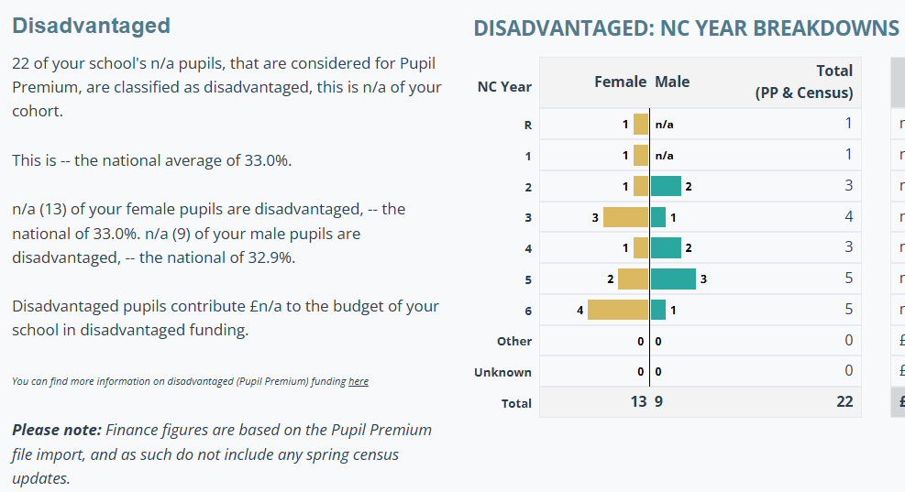
Attendance | 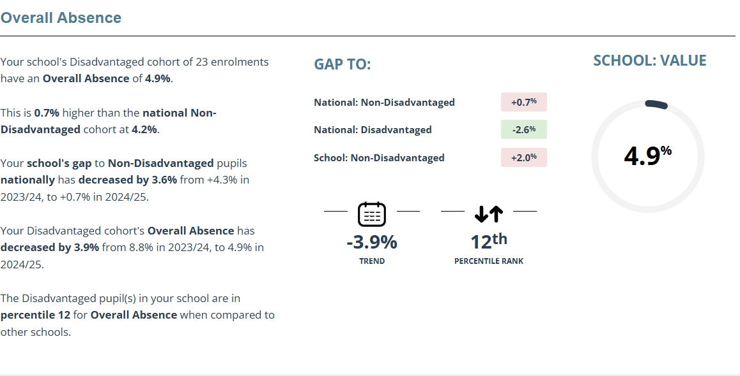
GLD | 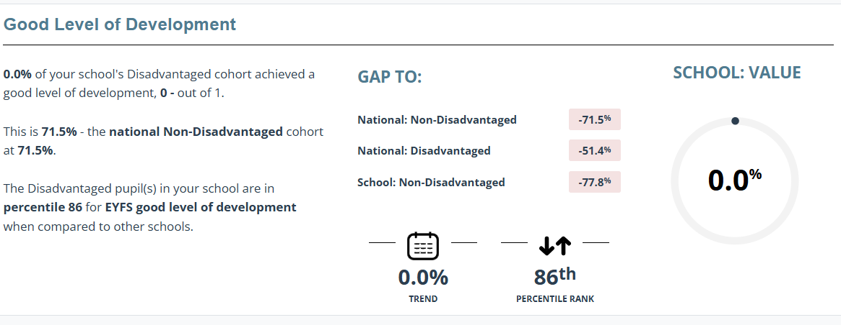  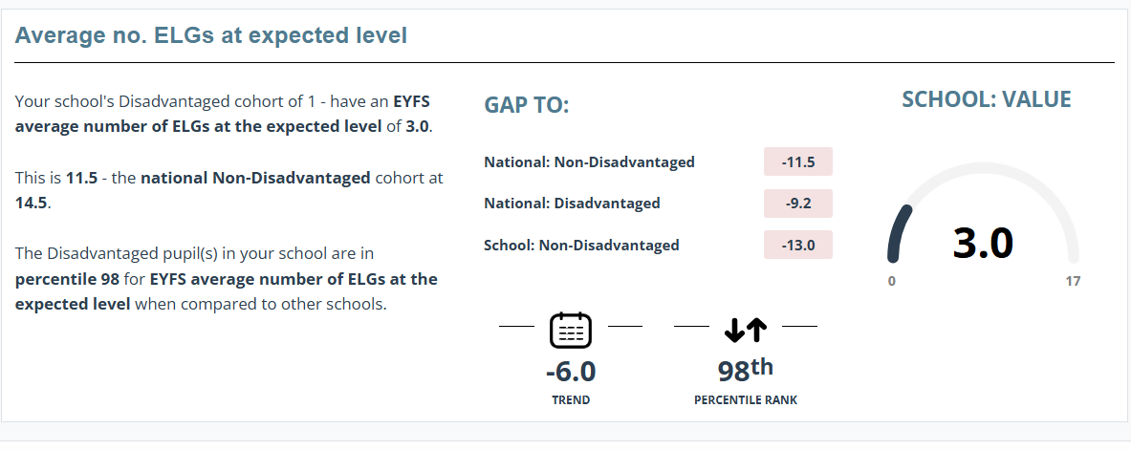
Phonics | 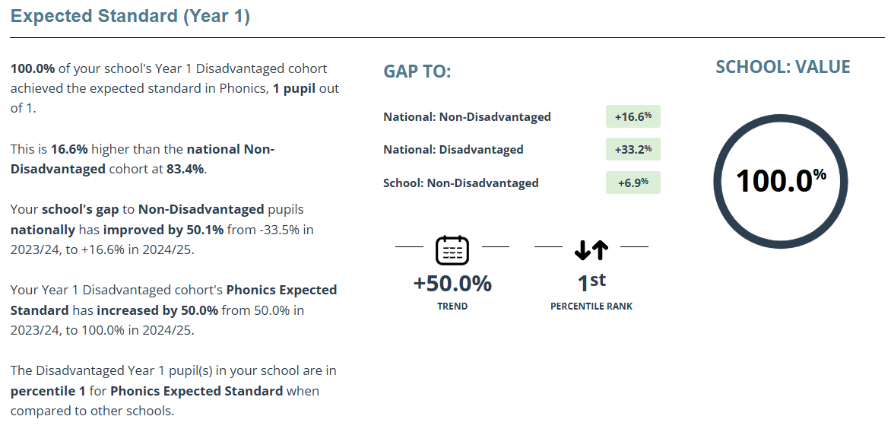  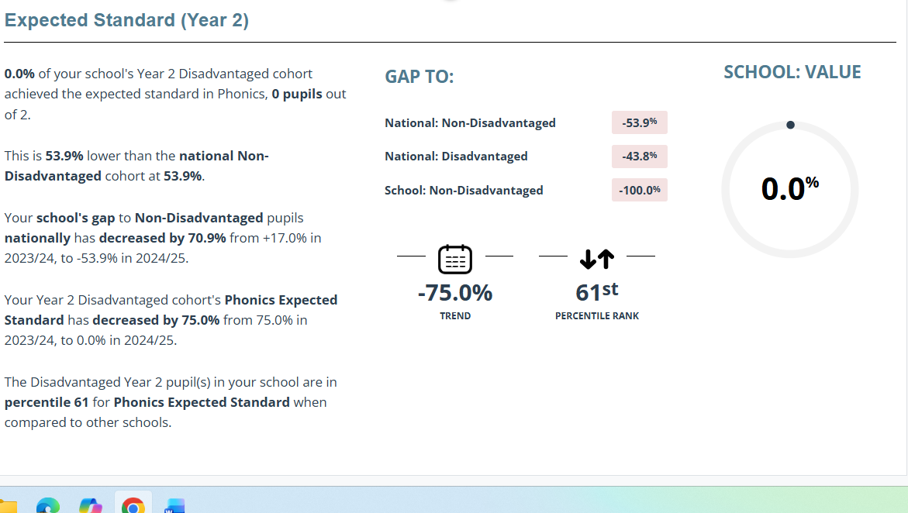

MTC
KS2 | 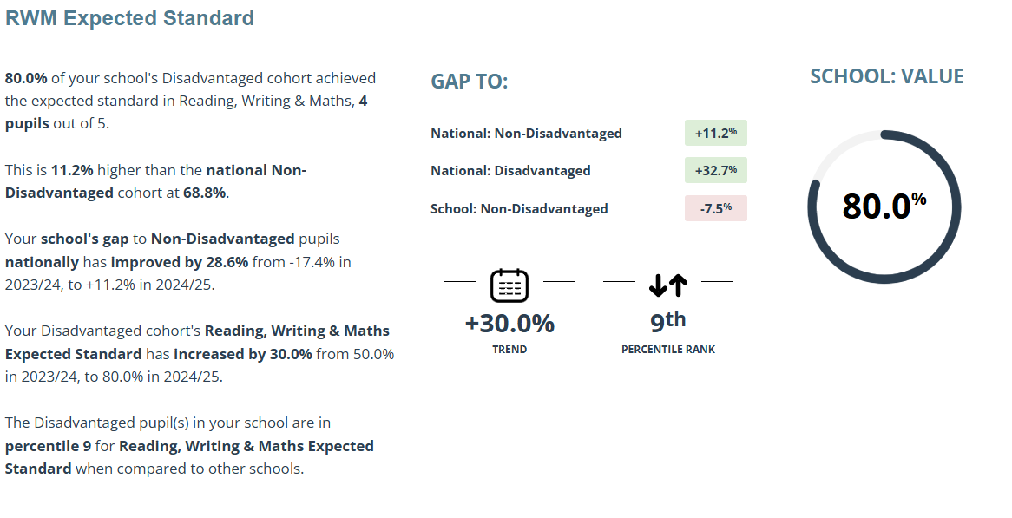  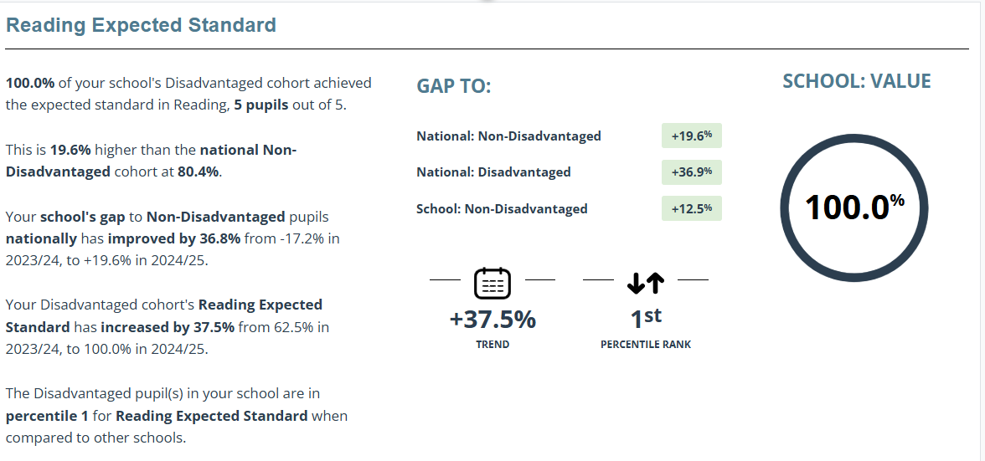  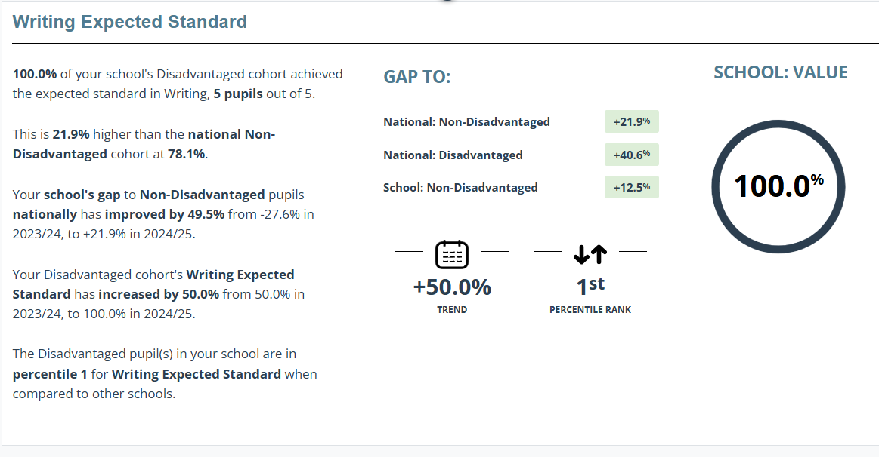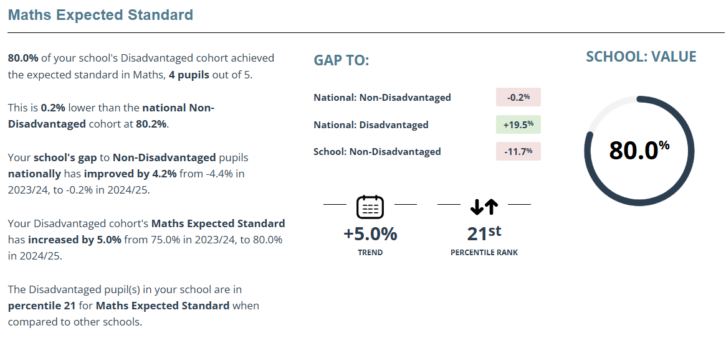  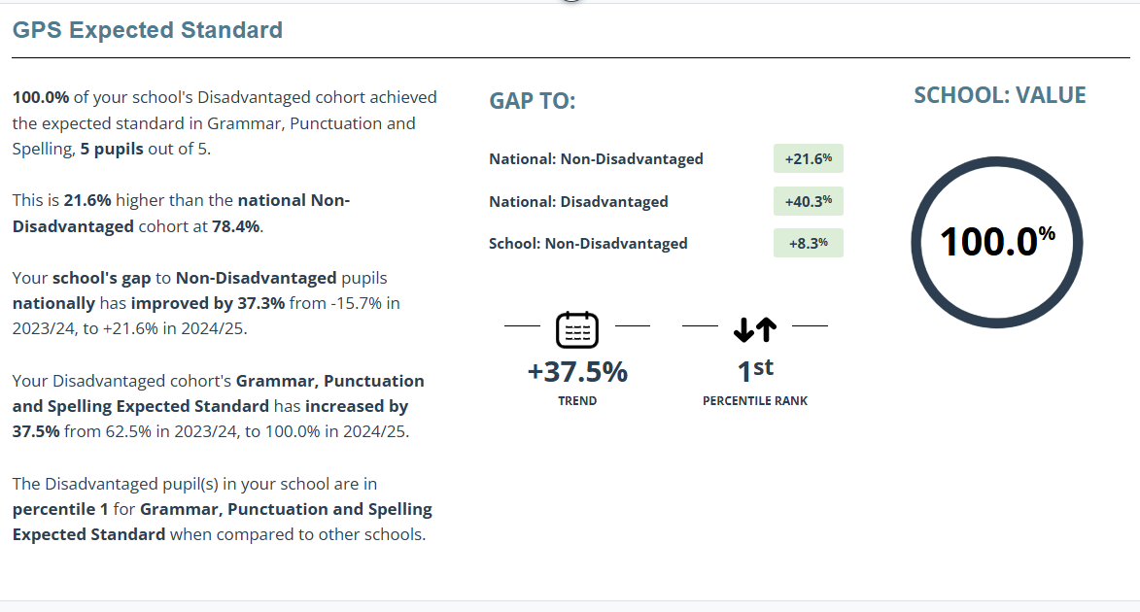
Outcomes  Close the gap between Pupil Premium and non-Pupil Premium with regards to the % of children working at a combined level in Reading, Writing and Maths. | IMPACT  Outcomes for KS2 PP children were good as only 5 children in the cohort and 4/5 children achieving the expected standard.
Children to be exposed to a broad range of experiences and knowledge through a well-planned curriculum enhanced by educational visits, enrichment opportunities and extra-curricular activities. | All pupils were encouraged to attend Trips throughout the year including before and after school clubs and residential trips.  Pupils had opportunities to learn through Forest Schools which developed their metal health and wellbeing and increases their resilience.  Trips enhanced learning of Geography and History
To further develop the Communication and Language skills of all pupils | Pupils achieved EYFS CLL 89.7%  Phonics will be 93.3%+  Encourages teachers to integrate language-rich activities across the curriculum, promoting consistency and high expectations.
Quality first teaching incorporates the teaching and learning model based on Rosenshein’s Principals. | We have used Rosenshein’s Principals to support teaching and learning throughout the school which in turn has impacted the results seen in KS2.
PP children with additional SEND issues are provided for, in a bespoke way combined with SEND budget to enhance children’s access to the curriculum. Independent skills encouraged | • Strengthens inclusive practice and staff expertise.  • Positive impact on Ofsted outcomes and school reputation for supporting vulnerable learners.  • Focus on independent skills builds confidence, resilience, and life-long learning habits.  • Reduces over-reliance on adult support, preparing pupils for future success.

Externally provided programmes
Please include the names of any non-DfE programmes that you used your pupil premium to fund in the previous academic year.
Programme | Provider

Service pupil premium funding (optional)
For schools that receive this funding, you may wish to provide the following information: How our service pupil premium allocation was spent last academic year
The impact of that spending on service pupil premium eligible pupils

Further information (optional)
Use this space to provide any further information about your pupil premium strategy. For example, about your strategy planning, implementation and evaluation, or other activity that you are delivering to support disadvantaged pupils that is not dependent on pupil premium funding.

